COURSEWORK

Clothes 4 Men web application

Mr. Jarmekorn Techawichittra

13401753

7051CEM - Web Applications and AI

Dr. Nazaraf Shah

14 April 2023

Table of Contents

Introduction 3

Use case diagrams 4

Application Design 6

Database ERD diagram 6

Wireframes 6

**1. Customer view 6**

**2. Administrator view 9**

Evaluation Report 11

Evidence of Implementation 14

Sales prediction 21

# **Introduction**

Clothes 4 Men is an online shopping store that offers a wide range of men's clothing from various brands. Customers can easily create their accounts, which allows them to conveniently track their order history and enjoy a personalized shopping experience. With a simple and user-friendly interface, customers can easily browse through the available brands and products, add items to their cart, and make purchases online.

This web application provides a comprehensive range of functionalities including secure payment processing, shopping cart management, and customer account management. Moreover, it features an order-tracking system that makes it easy for both customers and employees to manage products.

In terms of structure, this project is developed using the JEE platform and follows the Model-View-Controller (MVC) architecture. The Model represents the data and business logic of the application. The View is responsible for rendering the user interface, combine with JavaScript to create a more interactive and provide user experience, and the Controller manages the flow of data between the Model and the View.

JSPs are used as the View component to generate dynamic HTML content, while servlets are used as the Controller component to handle client requests, interact with the Model, and generate HTTP responses. The database is used to store and retrieve data required by the application.

# **Use case diagrams**

Figure

Use a case diagram of online shopping.

This project serves users' needs, including new customers, registered customers, and administrators.

1. New Customers
   1. Users can create their accounts within the system.
   2. In case user attempts to log in with incorrect login credentials or without having created an account, the system should prevent them from accessing any account features until they have properly registered and logged in.
   3. Users can view products within the system and add items to their cart.
   4. Users can view summary orders and total prices.
   5. Users can remove from their cart, to adjust their order.
2. Registered customers
   1. Users can have the same capabilities as new customers.
   2. Users can proceed to the checkout process to finalize their order and complete payment. During checkout, they can be able to provide billing and shipping information.
   3. Users be able to track the status of their shipments and view detailed information about their orders.
3. Administrators.
   1. Users can create new categories.
   2. Users can add new products and products detail such as images, prices, and select categories.
   3. Users can view all products within the system, whether they are currently in stock or out of stock.
   4. Users can track all customer's orders, including the address of customers, orders of products, and quantity.
   5. Users can view all customers who already create accounts within the system.

# **Application Design**

## **Database ERD diagram**

Figure 2

Database of Clothes 4 Men

## **Wireframes**

### Customer view

Figure 3

Login page

Figure 4

Create account page

Figure 5

Home page

Figure 6

View products page

Figure 7

Checkout page

Figure 8

Tracking orders page (for customers)

1. Administrator view

Figure 9

Manage all Products page

Figure 10

Tracking order (for Administrators)

Figure 11

User manager page

# Evaluation Report

This project is developed using the JEE platform and follows the Model-View-Controller (MVC) design pattern. To improve the maintainability, and testability of the application, a DAO (Data Access Object) layer has been added. It would typically be responsible for managing the application's data access layer. The technology of this project is implemented by JDBC (Java Database Connectivity), JavaScript, and Bootstrap. The project started with designing the functionality and database, identifying the values and information that needed to be retrieved or updated from the database. However, deleting values from the database is a future plan.

The DAO layer is responsible for managing the application's data access layer, and it has been implemented using JDBC (Java Database Connectivity). The project uses a local MySQL database with XAMPP and runs JEE application on a local GlassFish server which can test application in closely resembles a production environment.

The Model component includes classes that represent the project, and the DAO provides the Model component with a way to store and retrieve data from the persistent database. It encapsulates the JDBC code necessary for interacting with a database and makes it easier to work with and more reusable across different functions.

The Controller component has been developed using Servlet, which manages the flow of data between the model and the view. It includes business and application logic.

The View component has been developed using JSP, which allows for managing the application's data and business logic. This component contains classes and methods that interact with the application's data, and it has been combined with Bootstrap, including CSS and JavaScript to create responsive and dynamic web pages with animations. JavaScript has been used to improve the user experience and make the system's functions clearer.

In conclusion, JEE platform is widely and suit for developing web applications which include design patterns and technology to make it high-performance and easy to develop.

**Code Description and Test Results**

|  |  |  |  |  |
| --- | --- | --- | --- | --- |
| **Test Case Description** | **Test Data** | **Expected Out** | **Actual Output** | **Pass/Fail** |
| Users can create new account | - | Email, password, name, and role of customer added into the database | Email, password, name, and role of customer added into the database | Pass |
| Login and authentication | If something went wrong, please try again! | Preventing users who don't have an account or who enter the wrong password from logging | Preventing users who don't have an account or who enter the wrong password from logging | Pass |
| Displaying products by category | - | Showing correct products in the category | Showing correct products in the category | Pass |
| The product can be added to the cart | Showing the amount of product in the cart | Product added to the cart | Product added to the cart | Pass |
| The product can be removed from the cart | - | The product is deleted from the cart | The product is deleted from the cart | Pass |
| Users can open the cart when there are no products added | Your cart is empty | Showing alert | Showing alert | Pass |
| Users can open the tracking order when there is no user account | No order history, please log in before using this page. | Showing alert | Showing alert | Pass |
| Users will not check out the order when there is no user account | Please register before making a purchase. | Showing alert | Showing alert | Pass |
| Unable to checkout order due to a problem with inserting order into the database | Something wrong please contact the support | Showing alert | Showing alert | Pass |
| Users can complete checkout successfully | successfully | Insert detailed order and status into the database and show the alert | Insert detailed order and status into the database and show the alert | Pass |
| Administrators can add new product | Product entered successfully | Product added to the database | Product added to the database | Pass |
| Administrators can add new Category | Category entered successfully | Category added to the database | Category added to the database | Pass |
| Tracking order individual users’ details | No order history, please log in before using this page | Users can see individual details. In case, the users don’t have an account will be alert | Users can see individual details. In case, the users don’t have an account will be alert | Pass |

A link containing files course work: [Web application coursework](https://livecoventryac-my.sharepoint.com/:f:/g/personal/techawichj_uni_coventry_ac_uk/Es406FOZmMxJtPrtcZ9GoyoBGRXKcjkEdPa61DNNSFZ0lg?e=tsZAbe)

# **Evidence of Implementation**

1. New customer

1.1 User can view all products on the home page and the Products page as shown in Figure 12.

Figure 12

Showing home page and products page.

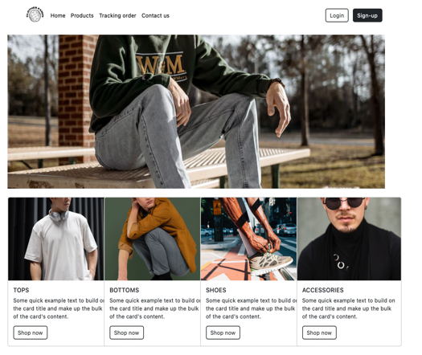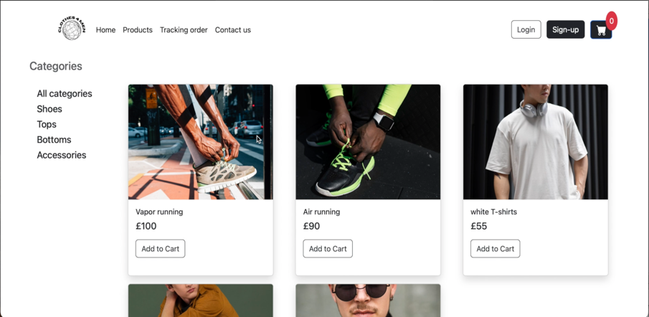

1.2 Users can filter categories by selecting the tab menu or they can select the button Shop Now from the home page as shown in Figure 13.

Figure 13

Jeans trousers products can be displayed by selecting shop now in the category bottoms or going to products and selecting Category bottoms.

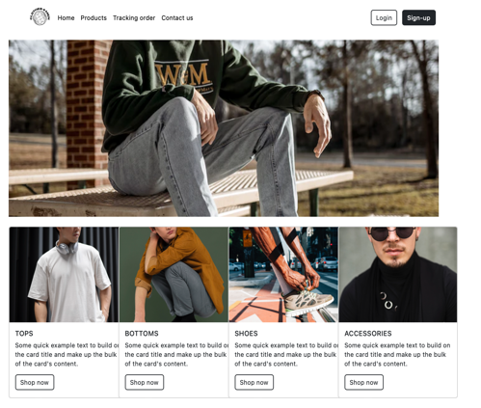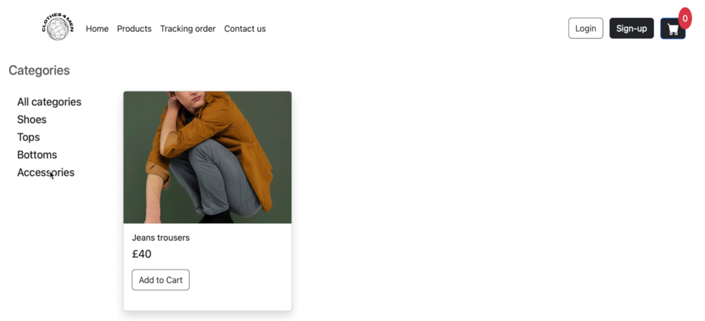

1.3 Users can add and remove the product from the shopping cart as shown in Figure 14.

Figure 14

Summary product list in shopping cart

1.4 Users can review their order and enter their payment and shipping information without checkout as shown in Figure 15.

Figure 15

Showing alert “Please register before making a purchase.” After clicking Checkout without login.

1.5 User can’t view tracking order before login.

Figure 16

Tracking order page with alert “No order history, please login before using this page.”

1.6 User can create their account as shown in Figure 17.

Figure 17

Create an account page.

2. Registered customer

2.1 Users can’t have authentication in case they provide the wrong email or password as shown in Figure 18.

Figure 18

Login page with wrong email or password.

2.2 User allows to filter and sort the products based on their preferences same as a new customer.

2.3 User can add and remove the product from the cart same as a new customer.

2.4 User can add a Visa credit card number of 16 digits and check the criteria as shown in Figure 19.

Figure 19

Checking criteria of Visa credit card number.

2.5 After checkout order will pop up an alert successfully as shown in Figure 20.

Figure 20

Successfully pop-up after completing checkout order.

2.6 User can track their order as shown in Figure 21.

Figure 21

Tracking order and details

3. Administrator

3.1 User can view all products in the system as shown in Figure 22.

Figure 22

Total lists of products in the system.

3.1 Users can add new categories as shown in Figure 23.

Figure 23

Inserting category name.

3.2 Users can add new products and details as shown in Figure 24.

Figure 24

Inserting Product name and details

3.3 Users can view all orders of customers in the system as shown in Figure 25.

Figure 25

Display tracing order of all customers.

3.4 Users can view all user accounts in the system as shown in Figure 26.

Figure 26

Display all user accounts.

3.5 After the user add a new product and category as shown in Figure 27.

Figure 27

Display product by filter category after added in the system.

# **Sales prediction**

Figure

Linear regression by using Python to predict the sale in 2024.

The result of predicted sales for the year 2024, which is based on the 20% increase in advertising cost for 2022, is approximately 13702.88 by using linear regression for analysis.

Linear regression is the technique that was chosen for this analysis because there is simple and wide to determine the relationship between 2 continuous variables (independent and dependent variables) in the form of a linear equation. In this case, both advertising cost and yearly sales are continuous variables that predict sales for the year 2024 by increasing advertising cost criteria.

Linear regression can be used to predict the value of the dependent variable (yearly sales) based on the independent variable (advertising cost). Therefore, linear regression is an appropriate technique to predict sales for the year 2024.